What is Mydetails Digital Cards?
Digital business cards are the way of the future. We have some things in mind, first is to make you sell more, second is to make your business looks professional, standard and credible. If you want your business to look BIG, Serious, Professional and Standard then consider Mydetails Digital Card.
Mydetails.com.ng is a Digital Business Profile Card platform where you can easily create unlimited digital cards for yourself and employees. Digital business cards offer numerous benefits that put you in a better position to win more clients and expand your professional business.
It is just like your physical business cards you offer to your customers to patronise you, however, mydetails digital cards offer much more benefits and advantages over physical cards. For example, you can upload your products and services, product's videos, testimonies, update your customers in real time etc
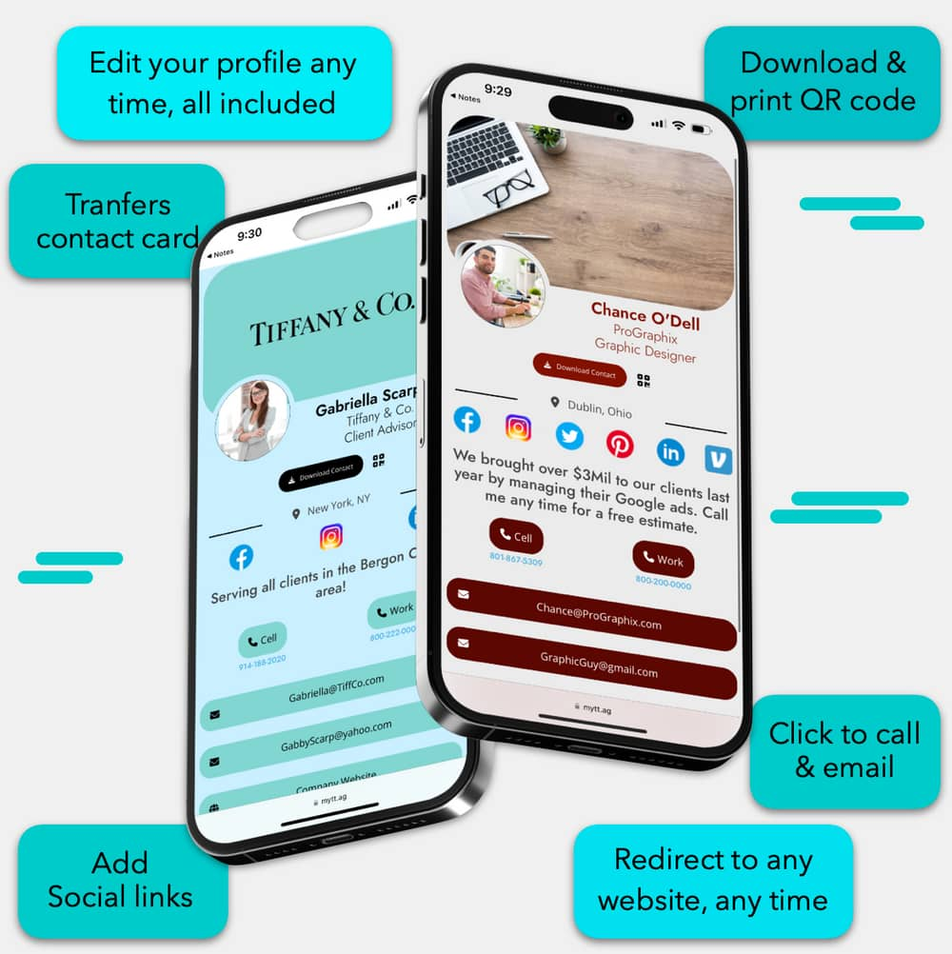
How can I place my order?
Simply sign up on our website at https://smartcard.mydetails.com.ng

How much does it cost?
Depending on what you intend to order

- Mydetails Digital Platform Pricing starts from ₦7,000.
- Mydetails NFC Cards (1pc) start from ₦35,000
- Mydetails QR Code (100pc) starts from ₦25,000. Number one is compulsory while 2 and 3 are optional

How can people access my information?
If you order Mydetails NFC Card, Simply tap your phone on the card to access the information. Alternatively, you can scan the QR code on the card and share directly from your phone.
If you order Mydetails Smart Cards, the QR Code should be scanned to access the information
If you are on Mydetails Digital Platform, simply share your link or QR Code with other

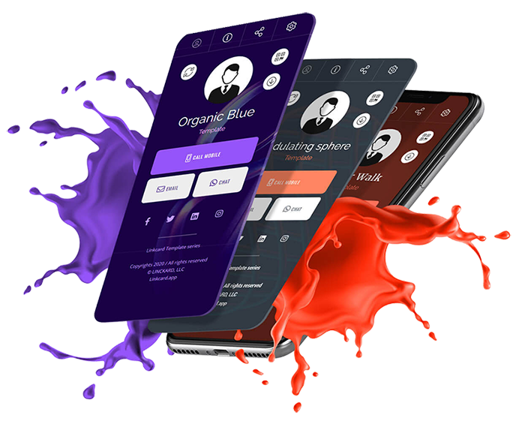
What information can I store on Mydetails Digital Card?

You can store various types of information, such as contact details, products and services, testimonies, FAQs, Videos, Photos, Articles, website URLs, social media profiles, portfolio links, About Us, Opening Hours, and more. You can even password your cards

Is the NFC technology compatible with all smartphones?
Yes, NFC technology is supported by the majority of modern smartphones, regardless of their operating system (iOS, Android, etc.).

How do I customize the information on Mydetails business card?
You can easily customize the information on your Mydetails business card through our website's user-friendly interface. Update and personalize it as needed.
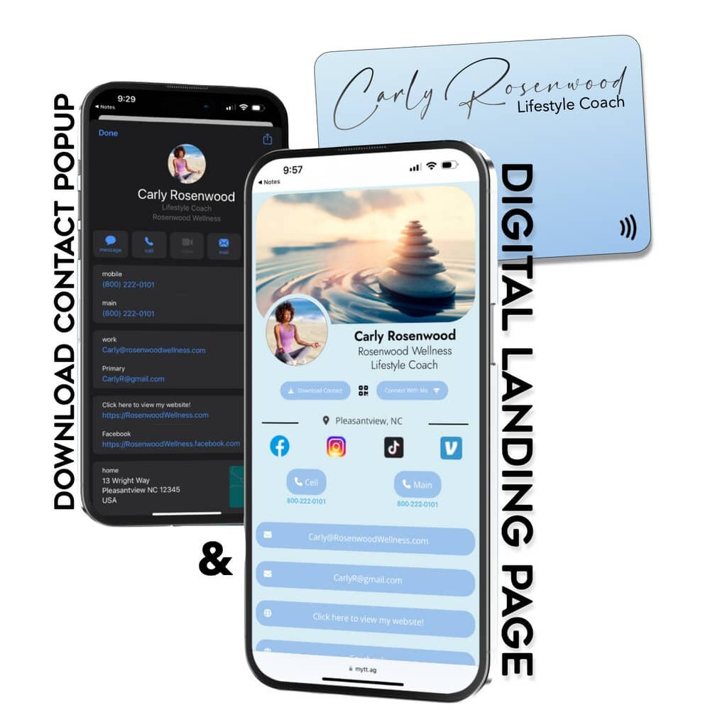

Digital business cards are the way of the future. We have some things in mind, first is to make you sell more, second is to make your business looks professional, standard and credible

